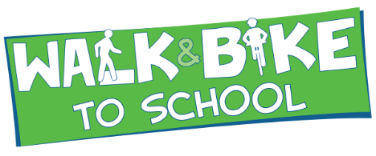

2018 REGISTRATION FORM

INTERNATIONAL WALK TO SCHOOL DAY – WEDNESDAY, OCTOBER 10, 2018

The organizations on the Making Kane County Fit for Kids board, now a 501c3 Not-for-profit, invite your school to participate in 2018 Walk to School Day activities.

**When:** Wednesday, October 10, 2018.

**Who:** Elementary and middle schools in Kane County school districts

**What:** Fit for Kids will provide $150 to the Parent-Teacher Organization at each school that participates *&* meets the deliverables outlined on this form.

THANK YOU TO THESE ORGANIZATIONS THAT HAVE ALREADY COMMITTED TO SPONSOR THIS YEAR’S ACTIVITIES!











**Rotary Club of Batavia**

**Rotary Club of Geneva**



2018 REGISTRATION FORM

Parent Teacher Organization/School agrees to:

1. Go to [www.walkbiketoschool.org](http://www.walkbiketoschool.org) and register your school’s event for 2018.
2. Promote International Walk to School Day event to parents by including information in parent newsletters and on school website using the Fit for Kids logo.
3. Distribute Walk to School Day brochure *electronically* to all school students. (Will be made available to schools by October 2, 2018).
4. Display a banner or sign, made by the school, celebrating the event. Allow participating students to sign the banner/sign.
5. Complete and submit data collection form. (Form will be made available upon registration).
6. Submit electronic copies of at *least* three pictures of the day’s activities that can be used on the Fit for Kids website and social media. Include at least one picture of the banner.
7. Post at least one picture of the event on Facebook and tag Making Kane County Fit for Kids. We encourage, but don’t require, you to like our Facebook page. [www.facebook.com/fitforkids](http://www.facebook.com/fitforkids)

Check out our website at [www.makingkanefitforkids.org](http://www.makingkanefitforkids.org) to stay connected!

*School Name: _____________________________________________________________________________­­­­*

PTO or School Contact Name: ______________________________________________________________

Telephone: ___________________________________ E-mail: ____________________________________

School Address _______________________________ City: ______________________________________

District: _____________________

Please return this form to [romanterry@countyofkane.org](mailto:romanterry@countyofkane.org) or fax it to 630-264-1880 by October 1, 2018.

Questions? Call us at 630-208-3140.



