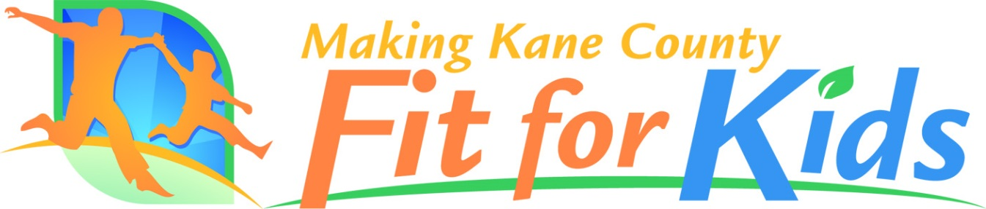

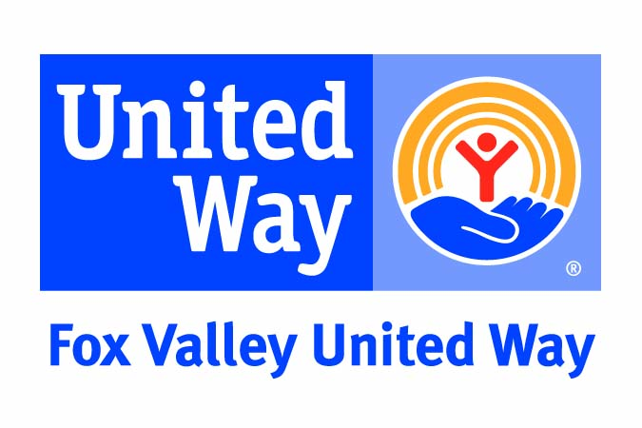
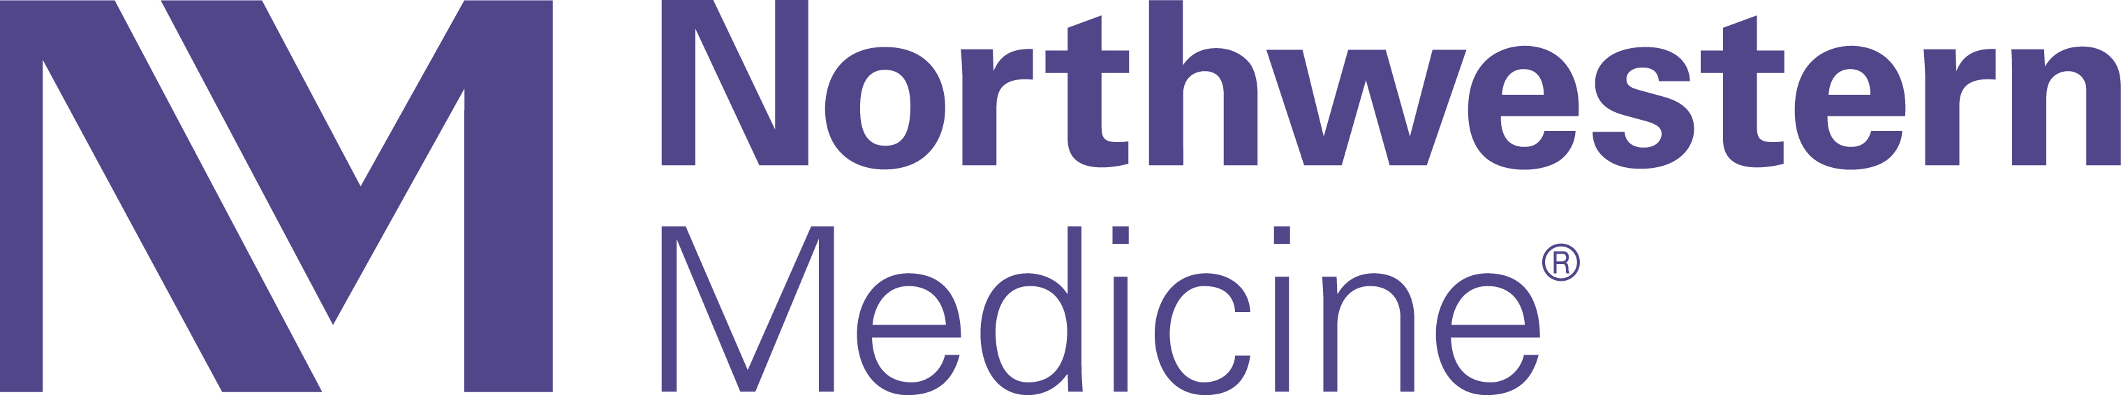
Remit Electronic Copy of Completed

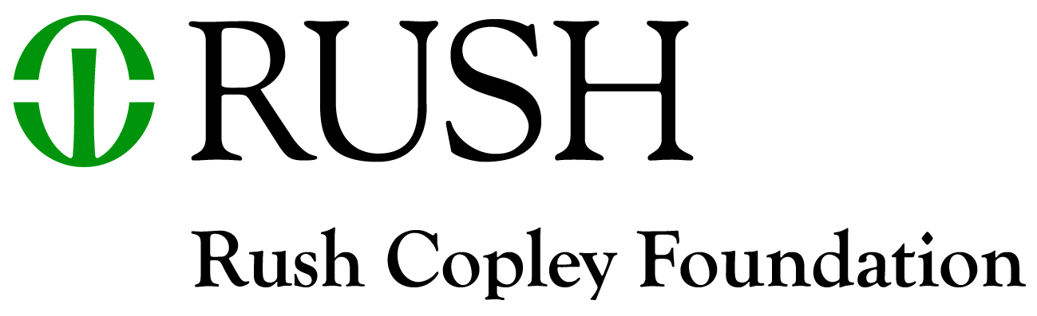
Application to:
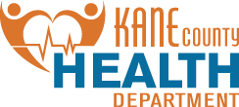
Making Kane County Fit for Kids
c/o Michael Isaacson at:
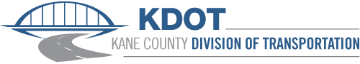
isaacsonmichael@countyofkane.org

Due Date: Monday, November 15th, 2021

TOWER GARDENS and STATIONARY BIKES YEAR 3
Healthy Eating and Active Living Educational School Initiative

Support for this Project has been provided by the KANE COUNTY BOARD through its OFFICE OF COMMUNITY REINVESTMENT with funds from GRAND VICTORIA RIVERBOAT CASINO

Additional Major Supporters Include:

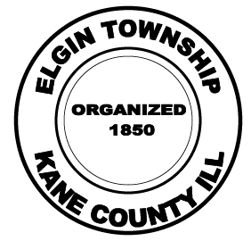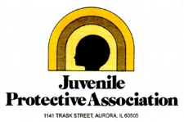

Making Kane County Fit for Kids Board Organizations

Making Kane County Fit for Kids

General Purpose
Making Kane County Fit for Kids (Fit for Kids) is making funding available to community organizations to support projects in Kane County that increase physical activity and healthy eating in the various sectors of the community described in the Fit Kids 2020 plan.

Brief History and Description of the Making Kane County Fit for Kids

In 2008, the Kane County Board launched the Making Kane County Fit for Kids Initiative at the Fit for Kids Leadership Summit. Following the Summit a public-private partnership, the “Fit for Kids Funders’ Consortium” was established. In 2017, Making Kane County Fit for Kids became a 501c3 not-for-profit organization. Organizations with members on the board include: Fox Valley United Way, Kane County Division of Transportation, Kane County Health Department, Northwestern Medicine- Delnor Hospital, and the Rush Copley Foundation.

By combining forces, these partners believe they can most efficiently and effectively raise and disperse funds to support the comprehensive, coordinated; community-based initiatives needed to Make Kane County Fit for Kids and implement the Fit Kids 2020 Plan., Making Kane County Fit for Kids has made over $900,000 available to community partners to support local efforts to reduce obesity in the community and implement the Fit Kids 2020 Plan. These funds have been and will continue to be made available to community organizations, municipalities and coalitions that implement strategies consistent with the Making Kane County Fit for Kids goals.

The Fit Kids 2020 Plan is a strategic plan to reverse childhood obesity in Kane County by 2020 and was published in 2011. The Fit Kids 2020 Plan represents the work of over 80 community stakeholders, meeting over 6 months, contributing well over 1,000 hours of volunteer time. Workgroups dedicated their time to researching, meeting and discussing potential strategies
and action steps. This process shows the investment and dedication of the participants in the future of Kane County.
Nine sector-specific Fit Kids 2020 workgroups created this written set of policy level strategies and action steps. Implementation of the more than fifty strategies will lead to local systems, policy and environmental change in Kane County public and private institutions, communities, schools, and families that, together, will assure the conditions for healthy eating and active living across Kane County. The Fit Kids 2020 plan can be viewed at: http://www.makingkanefitforkids.org/site/data/FFK_2020_Plan.pdf

DETAILS ABOUT UPDATING THE FIT KIDS 2020 PLAN
WILL BE RELEASED LATE 2021

Eligible Applicants

This funding is available to public and private schools in Kane County school districts. Funding will not be made available to individuals. Funding will be used exclusively for the purchase of equipment and supplies related to tower gardens and stationary bikes. To promote an increase in physical activity and healthy eating in schools.

Project Eligibility

Agreements will be entered with organizations for projects ranging between $500 and $10,000. At this time Making Kane County Fit for Kids expects to distribute up to $30,000 with the average awards anticipated to be around $5,000.

All projects must include data collection and project impact evaluation. This includes providing data to Fit for Kids that includes: demographic data of target population served by the grant, participation numbers and outcome data. Fit for Kids representatives will work closely with applicants to assure successes are documented. In addition to data collection, this will include collecting photographs, stories and videos of those impacted by the project. These materials will be utilized to highlight the great work going on in the community to improve health.

Review Criteria

Applications that meet eligibility requirements and are received by November 15th, 2021 will be evaluated on a competitive basis according to the criteria listed below.

Criteria | Description
Evaluation and Assessment | Projects must include data collection and project impact evaluation. This includes providing 3 types of data:  - demographic data of target population served by the grant  - participation data  - outcome data
Project Readiness | Priority will be given to projects that are ready to proceed or face the fewest obstacles that could prevent their timely completion.
Community Impact/Urgency | Priority consideration will be given to projects expected to have the greatest beneficial impact on high-risk or at-risk populations, including low-income and racial/ethnic minority populations.

Submission Requirements

Applications for Fit for Kids funds must be submitted electronically using the forms provided in this packet. In addition to the required forms, a number of supporting documents are required. (An application checklist is provided at the end of the application packet for reference purposes.)

Applicants should be certain to properly complete and submit all required application materials, as insufficient data could reduce the competitiveness of an otherwise eligible project.

Applications for Making Kane County Fit for Kids funds are due by 4:30 PM on Monday, November 15th, 2021.

Please submit an electronic copy of the completed application to isaacsonmichael@countyofkane.org. Making Kane County Fit for Kids reserves the right to request additional information regarding any application submitted.

For Further Assistance

The staff of the Kane County Health Department and Fit for Kids are available to answer questions regarding application procedures, project eligibility requirements, and Making Kane County Fit for Kids in general.

Please contact Michael Isaacson, Assistant Director of Community Health, at 630-208-3140 or isaacsonmichael@countyofkane.org for further assistance.

Additional information is also available at www.makingkanefitforkids.org.
Making Kane County Fit for Kids- Call for Projects
2021 Application

APPLICATION INFORMATION

School Name:

School Address:

City, State, Zip:

Contact Name and Title:

Phone: ( ) -

E-mail:

Project Period: January 2022- December 2022

PROJECT FUNDING

1. Total cost of project identified above: $

2. Total funds available (or to be secured) from other sources: $

3. Amount requested from Making Kane County Fit for Kids: $

Attach a budget for the project. Include all project expenses and funding sources. Indicate the status of each funding source (i.e. yet to apply, application pending, funding committed, etc.).

FIT FOR KIDS GRANT PROJECT GOALS GRID AND QUESTIONNAIRE

Project Summary: (Provide a general statement explaining the problem/opportunity the project will address and identify the benefits of implementing the project)
Target Population of your organization and project

Project Goal(s)
 | Methods or process to reach your goal | How will you know you met your goal?  Measures and data collected
EX: This project is intended to increase bicycle and pedestrian safety at the intersection of Maple Ave and Smith St to encourage more walking and biking. | EX: Signage will be installed on the blocks leading up to the intersection with speed indicator display. | EX: Vehicle and pedestrian traffic accident data will be obtained and analyzed for 3 year period before and after intervention.
 | EX: Crossing will be restriped to emphasize that pedestrians are crossing the road at that location | EX: Interns from the organization will conduct brief survey of residents before and after intervention to evaluate perceptions about safety at the intersection.
(Each goal will have at least one method and measure. Expand the grid and add more boxes to the table if needed)

In addition to completing the grid above, please provide short answers to the questions below.

Project Questions

1. Provide a detailed description of your project/program, including the target population and geographic area it will serve.

2. Describe the applicant’s experience in the administration of this or similar projects/programs, including the qualifications of personnel that will be directly involved in the management of this project/program.

3. Is this project/program a collaborative effort with other entities? If so, please elaborate.

Organization Questions

1. Briefly describe your organization and its history. Include website and/or Facebook page if applicable.

APPLICATION CHECKLISTS

In order to be considered for funding, applicants should submit a properly completed application form, the applicable questionnaire, and a variety of supporting documents, depending on the type of project or program proposed. A list of the required documents for each type of activity is provided below.

- Completed application, including project goals grid and questionnaire
- Project budget (itemize all project expenses and funding sources)
- Project timeline (attach a schedule for completing the project with key target completion dates listed)
- Completed invoice from your vendor showing total cost of project.
- Must be willing to deposit the checks or be ready for Fit for Kids to write checks to the vendor within a couple of weeks.
Applicant certifies that they have read and fully understand the guidelines that govern the Making Kane County Fit for Kids 2020 grant program. Applicant further certifies that all information furnished in/with this application is true and complete to the best of Applicant’s knowledge and belief. If any information provided herein changes following the submission of this application, Applicant agrees to notify Fit for Kids, immediately. Applicant acknowledges that Fit for Kids may verify any information contained in/with this application, and submission of this application shall constitute Applicant’s authorization for Fit for Kids to complete such verification as it deems necessary to determine the accuracy of this application and its suitability for funding. Applicant understands and agrees that if false information is provided in/with this application, which has the effect of increasing Applicant's advantage, Fit for Kids may disqualify this application and deem Applicant ineligible to receive any funds in the future. Applicant understands that Fit for Kids retains the right to reject any and all applications, and, in its sole determination, to waive minor irregularities. Applicant acknowledges by execution of this application that Fit for Kids will make such determinations with the fullest discretion allowable by law. Applicant will at all times indemnify and hold harmless Fit for Kids against all losses, costs, damages, expenses and liabilities of any nature directly or indirectly resulting from, arising out of, or relating to the Fit for Kids’ acceptance, consideration, approval, or disapproval of this application and the issuance or non-issuance of funds herewith. Applicant further certifies that they do not discriminate on the basis of race, religion, color, sex, age, handicap or national origin; and that they are duly authorized by board resolution to cause this document to be executed.

Signature Date

Name (Printed) Title (Printed)

