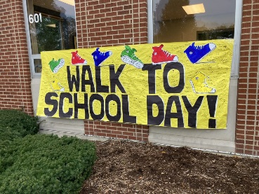



**October 5, 2022**

**Sponsorship Levels**

**TITLE SPONSORSHIP - ALDI**

* **Recognition** **on Marketing Materials: Posters** **at all participating Schools & Flyers** sent electronically to **all student homes**.
* Headliner in **Media Release** with your boilerplate and comments, including Kane County Connects - **10,000 readers**.
* Top Promotion on **Making Kane County Fit for Kids Website and Facebook.** Link to your Business or Organization.
* **Award or Plaque** for your company or organization.

**GOLD SPONSORSHIPS - $2500**

* **Recognition on Marketing Materials: Posters** **at all participating School & Flyers** sent electronically to **all student homes.**
* Name Inclusion in **Media Release** with your brief boilerplate, including Kane County Connects – **10,000 readers.**
* Promotion on **Making Kane County Fit for Kids Website and Facebook.** Link to your Business or Organization.
* **Award or Plaque** for your company or organization site.

**SILVER SPONSORSHIPS - $1000**

* **Recognition on Marketing Materials: Posters** **at all participating Schools & Flyers** sent electronically to all **student homes**.
* Name Inclusion in **Media Release,** including Kane County Connects – **10,000 readers.**
* Promotion on **Making Kane County Fit for Kids Website and Facebook.** Link to your Business or Organization.

**BRONZE SPONSORSHIPS - $500**

* **Recognition on Marketing Materials: Posters** **at all participating Schools & Flyers** sent electronically to **all student homes.**
* Name Inclusion in **Media Release,** including Kane County Connects – **10,000 readers.**
* Promotion on **Making Kane County Fit for Kids Website and Facebook.** Link to your Business or Organization.

**------------------------------------------------------------------------------------------------------------------------------------------------**

**SPONSOR NAME (as you would like it to appear)** ________________________________________________

**SPONSOR ADDRESS** ________________________________________________

________________________________________________

**CONTACT NAME**  _________________________________

**PHONE Business** _________________________ **Cell** ___________________________

**SPONSOR LEVEL TITLE  GOLD  SILVER  BRONZE **

**DONATION AMOUNT** ___________________­­­______________

***Your Sponsorship will be used in support of Walk to School Day and the mission of Making Kane County Fit for Kids***

**Thank you for your Sponsorship Donation for Walk to School Day 2022!**

**DONATION PROCESS**

**Making Kane County Fit for Kids is an IRS recognized 501(c)(3) nonprofit organization – EIN # 82-0791501**

1**) Please fill in above Sponsorship Information and send copy with your donation.**

2**) Write Check to Making Kane County Fit for Kids.**

**3) Mail to Making Kane County Fit for Kids, 1240 N. Highland Ave Ste 24, Aurora, IL 60506**

**Attention: Michael Isaacson**

***Questions or for more information: Susan Ericson –*** [***smericson@comcast.net***](mailto:smericson@comcast.net) ***or 630-768-8044 (mobile)***

**Making Kane Fit for Kids is a**