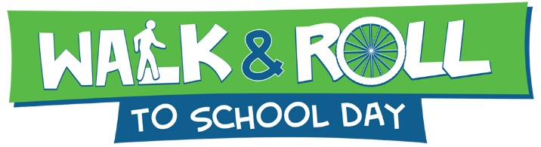

After-Event Report
We hope you had a fun event!
Please return this form to PetersonLiliana@KaneCountyIL.gov or fax to 630-264-1880 by 10/30/23

School Name: Click or tap here to enter text. District # Click or tap here to enter text.

PTO or School Contact Name: Click or tap here to enter text.

Telephone: Click or tap here to enter text. E-mail: Click or tap here to enter text.

School Address/City: Click or tap here to enter text.

- How many children are enrolled at the school? Click or tap here to enter text.

- What is your typical average number of daily walkers and bikers? Click or tap here to enter text.

- How many students participated in Walk & Bike to School Day on October 12? Click or tap here to enter text.

- Briefly, describe your school’s activities to for International Walk to School Day? Click or tap here to enter text.

- Did people outside of the school community participate in your event? Who? How did they participate? Click or tap here to enter text.

- What barriers at your school keep children from walking or riding their bike to school? Click or tap here to enter text.

- What will you do between now and Walk & Bike to School Day 2023 to promote walking? Click or tap here to enter text.

- How does your school promote healthy eating and active living for your students and staff? Click or tap here to enter text.

- How do you plan on using your grant from Fit for Kids? Click or tap here to enter text.

- Please submit any media coverage that you are aware of, along with at least three pictures of the day’s activities that can be used on the Fit for Kids website and social media after the event. Include at least one picture of the banner. Send via email to: PetersonLiliana@KaneCountyIL.gov

- Post at least one picture of the event on Facebook and tag @fitforkids. We encourage you to like our Facebook page at: www.facebook.com/fitforkids

