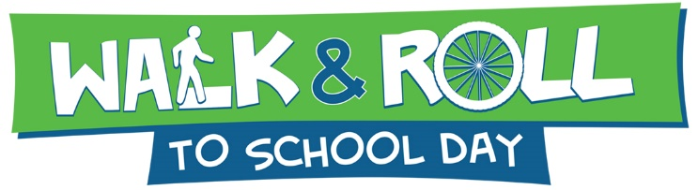

Walk & Roll to School Day is October 4, 2023

Kane County Elementary and Middle Schools are invited to participate in the 2023 Walk & Roll to School Day activities. Fit for Kids will provide $150 to each parent-teacher organization or school that participates! Schools are welcome to celebrate any day in October that fits their schedule.
2023 Registration Form
Parent-Teacher Organization/School agrees to:
- Register your event with Making Kane County Fit for Kids using this form or the electronic version available at: https://forms.office.com/r/AKMqXcPq0k

There is no need to additionally register with the National Walk to School site this year in order to receive the $150.00 from the Kane County Health Department for participation.

- Promote International Walk & Roll to School Day by including information in parent newsletters, your school website, and social media using the Fit for Kids logo (right click on the logo to copy or save image). You’ll find more tips for a successful event at: www.walkbiketoschool.org

- Distribute Walk & Roll to School Day flyer electronically to all school students. This will be sent to the contact indicated below by September 20, 2023.

- Display a banner or sign made by the school celebrating the event. Allow participating students to sign the banner/sign.

- Complete and submit the After-Event Report with photos by October 30, 2023. After receiving your report, your awarded $150.00 will be released.

- Promote the event on Facebook and tag @fitforkids. We encourage you to like our Facebook page at: www.facebook.com/fitforkids

- Check out our website at www.makingkanefitforkids.org to stay connected!

School Name: __________________________________________________ District #_________

PTO or School Contact Name: ______________________________________________________

Telephone: ____________________________ E-mail: __________________________________

School Address: ________________________ City: ____________________________________

Please return this form to PetersonLiliana@KaneCountyIL.gov or fax to 630-264-1880 by 9/29/23
Call us with any questions at 630-208-3801

1240 N. Highland Ave.
Aurora, IL 60506
(630) 208-3801
Authorization Agreement for Electronic Deposits

PTOs and schools have the option to receive their $150 participation grant by check or electronic deposit. Please indicate your preference and complete the information below if an electronic deposit is preferred.

☐ Yes, I would like to receive payment by electronic deposit
☐ No, please send a check to the school address indicated on the Registration Form

School: _____________________________________________

School Address: __________________________________________________________
Bank Name: _____________________________________________________________
Bank Address: ___________________________________________________________
Bank Account Number: ______________________
Routing Number: ___________________________
Type of Account: ______________________________________________

By signing below, you authorize Making Kane County Fit for Kids to initiate deposits into the bank account identified above. This authorization will remain in effect until Making Kane County Fit for Kids receives written notification from the authorizing agency to terminate or alter said agreement.
_____________________________________________________________
Signature

______________________________________________________________
Print Name

______________________________________________________________
Title

______________________________________________________________
Date

Please return this form to PetersonLiliana@KaneCountyIL.gov or fax to 630-264-1880 by 9/29/23

